1. Start – identify the person from RFL Master file
2. From RFL master – Laura identified emplid 10720905 and mark on RFL Master File to indicate that she’s working on this person.

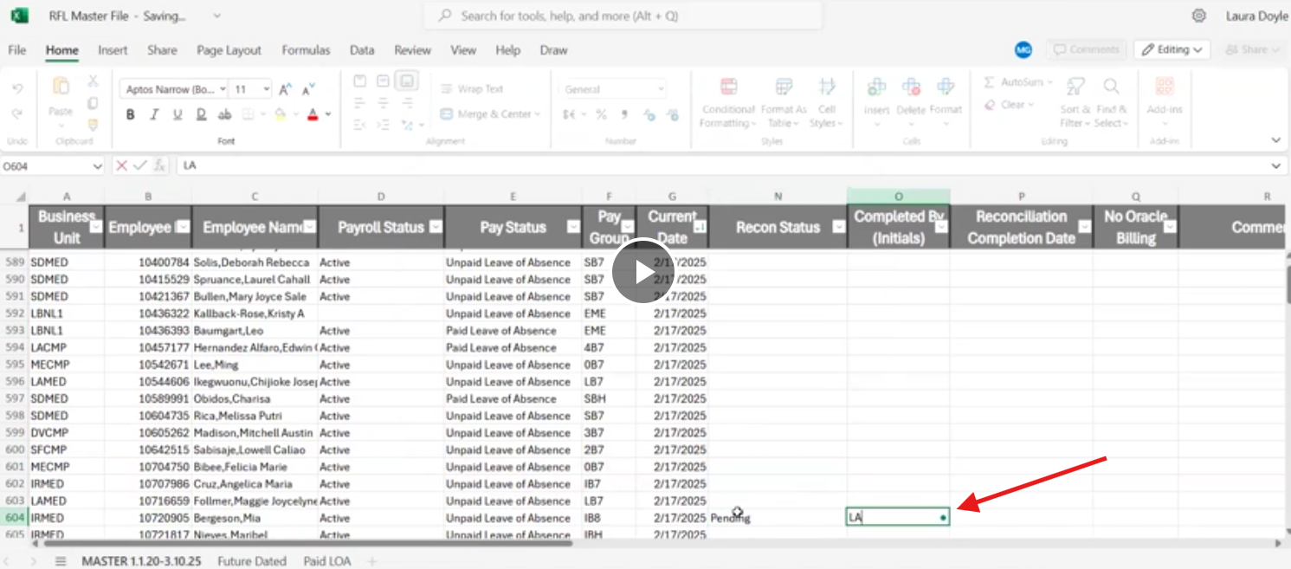

## Check if Employee Is Returned From Leave in PS > Job Data

1. Go PS > Job Data > types in **Emplid**

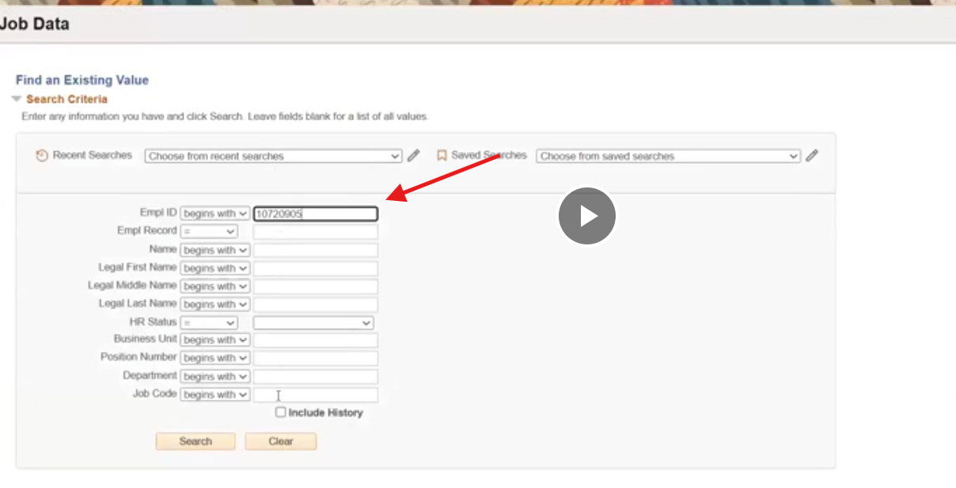

1. Check Action: Return From Leave, Effective Date:?, Payroll Status: Active

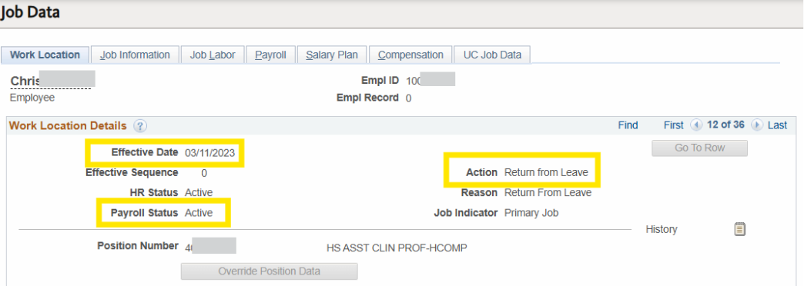

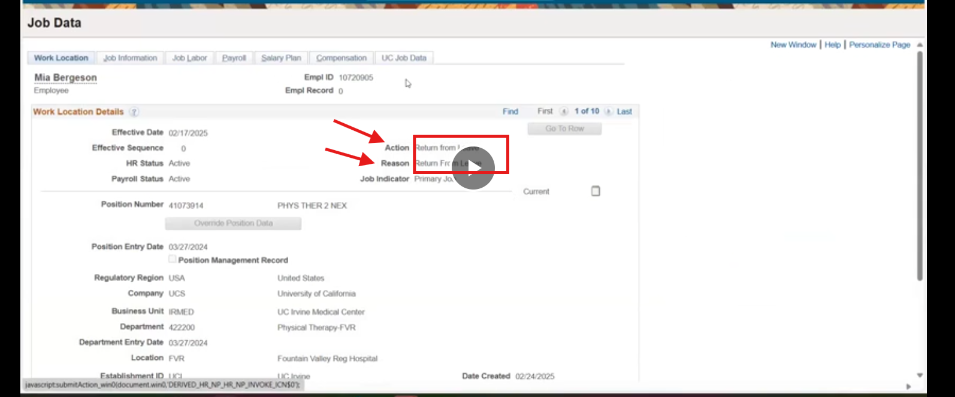

## Pull a Report FIN001 Deduction from Query Viewer

1. PS > Query Viewer > UC_FIN001_PAYCHECK_DEDUCTIONS
2. Click Excel

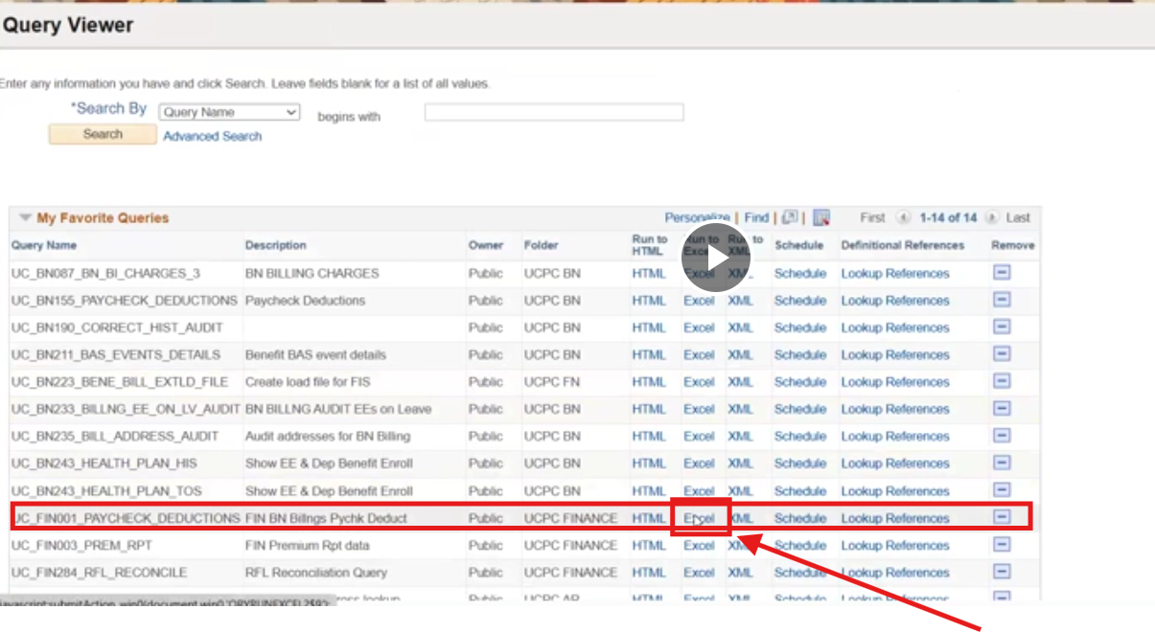

1. Type in **Emplid**

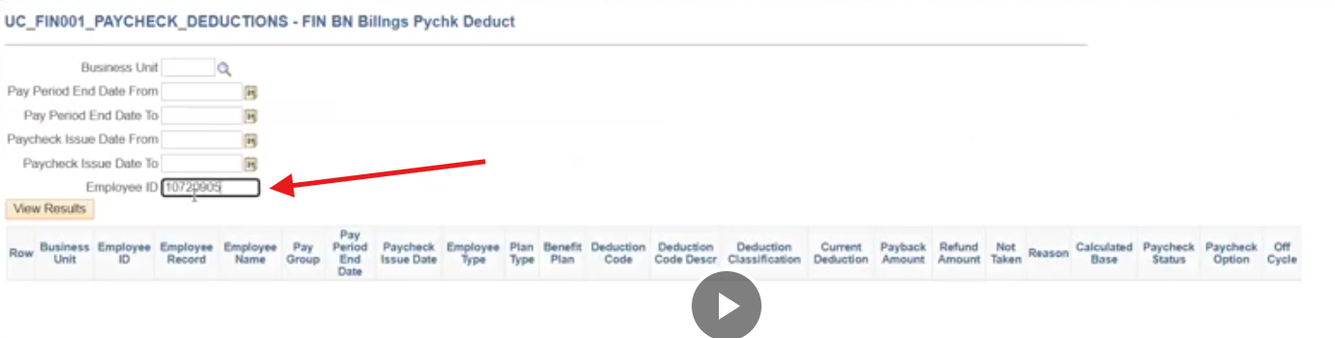

## Processing FIN001 report

1. When FIN001 report (Excel) is opened, run TEAM_001 macro to format

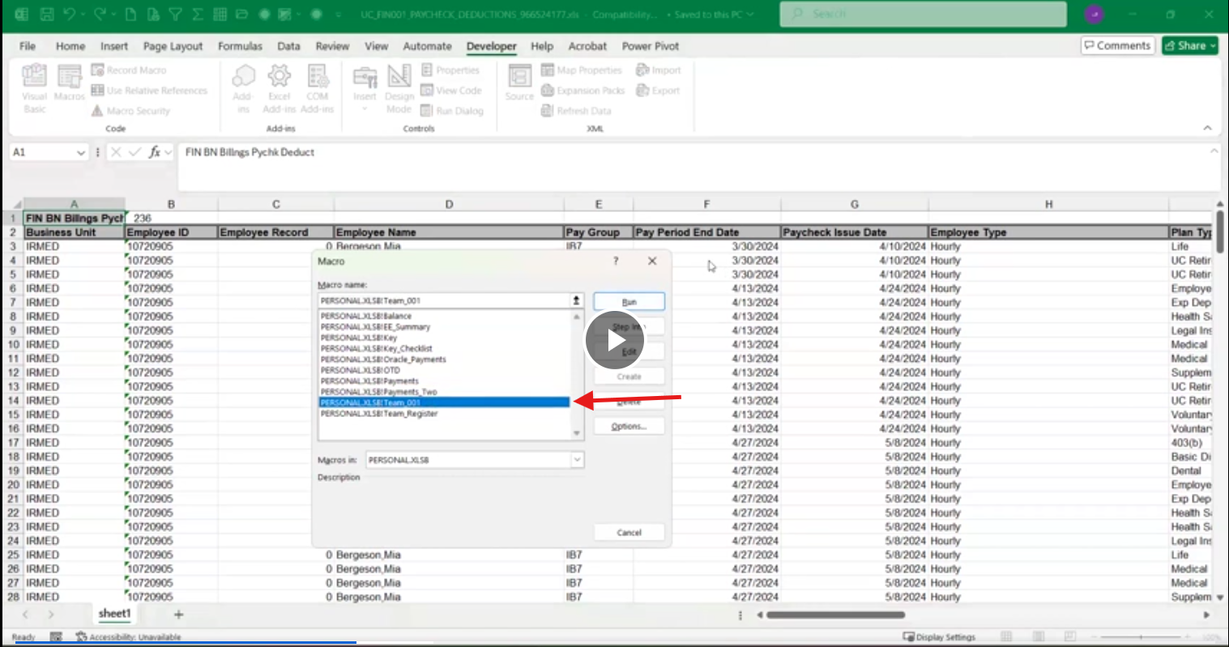

1. When TEAM_001 macro is ran:
   1. sheet is filtered on Plan Type = Medical, Deduction Class = Before-Tax
   2. created Summary, Register, Payments, Original_Reg, and Notes sheets
2. After TEAM_001 macro is ran, look for variances in column L and highlight them

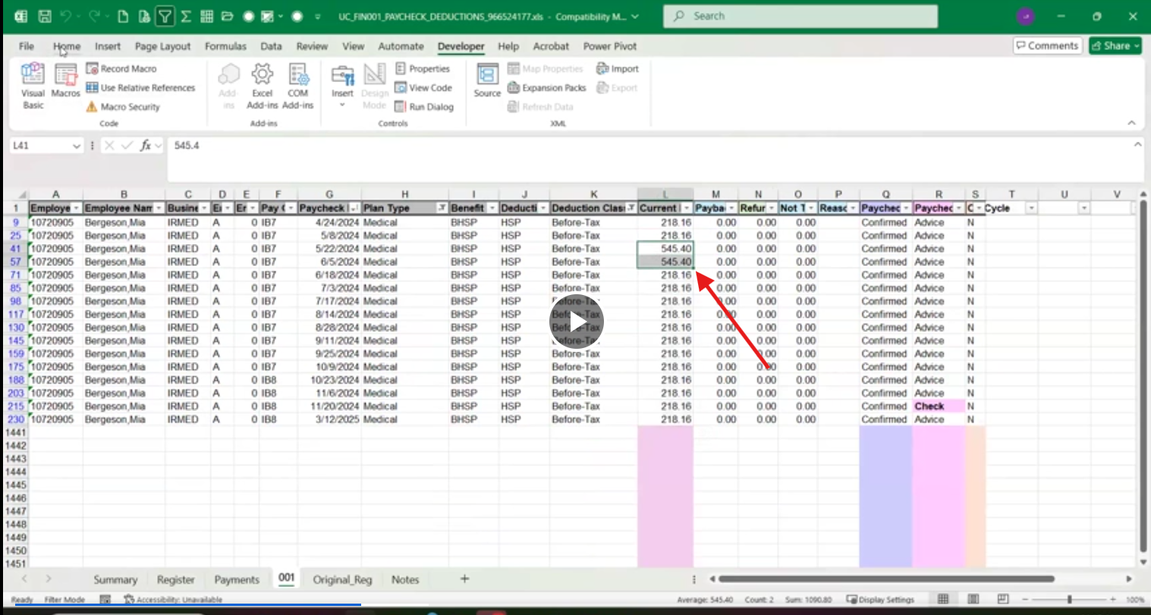

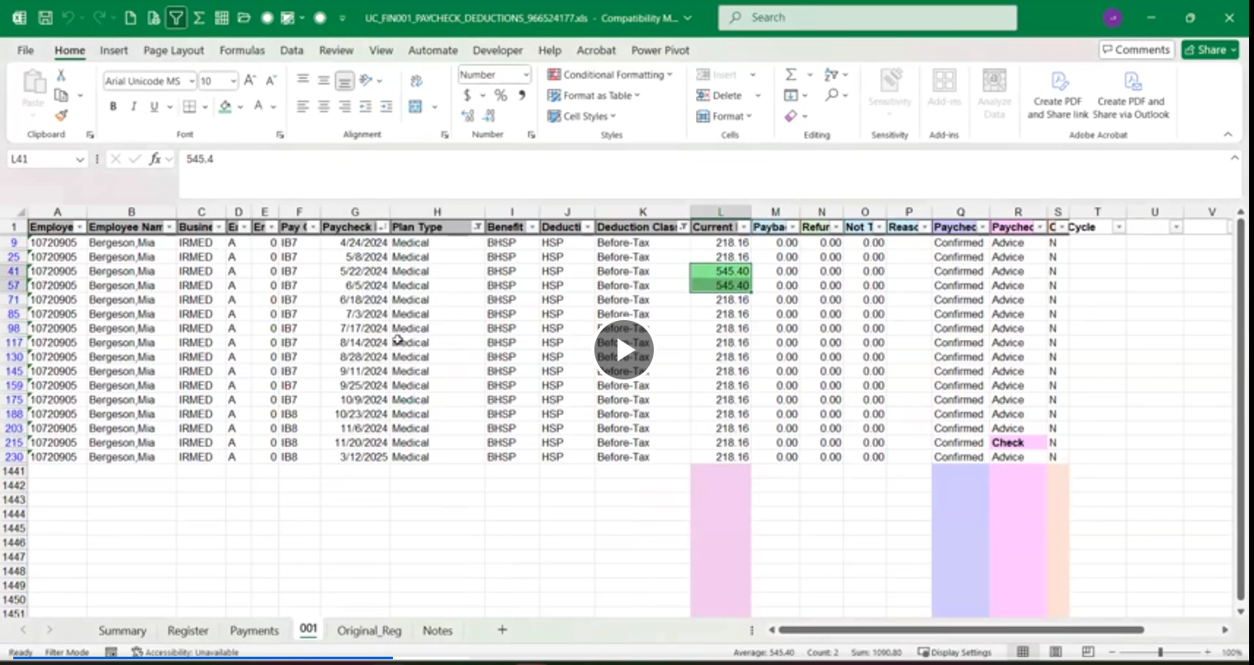

1. Look for any missed paycheck (or a gap) in Paycheck Issue date (column G)

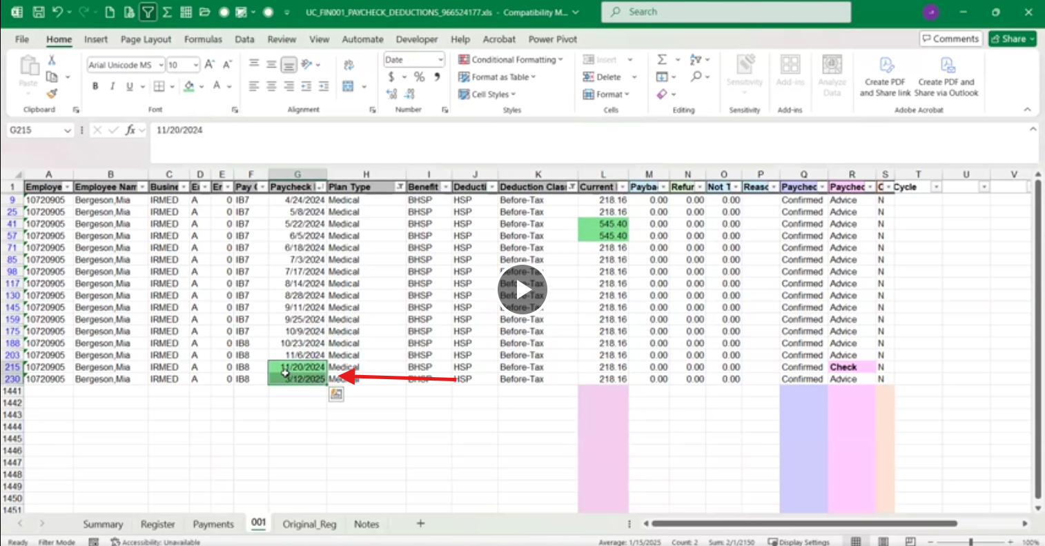

1. (Optional) Look for any variance in Benefits (column I)
2. Create a pivot from this filtered view
   1. Fields included: Paycheck Issue Date, Plan Type, Benefit Plan, Deduction Classification, Current Deduction
   2. Columns: Years(Paycheck Issue Date), Paycheck Issue Date
   3. Values: Sum of Current Deduction
   4. Rows :
      1. Plan Type (filtered on :Basic Disability, Dental, Employee & Dependent AD&D, Exp Dependent Life – Spouse/DP, Legal Insurance, Life, Medical, Supplemental Life, Vision, Voluntary Long Term Disability, Voluntary ShortTerm Disability)
      2. Deduction Classification
      3. Benefit Plan
   5. Add group selection:
      1. Select the year
      2. Select Group Selection under PivotTable Analyze menu
      3. On By: select Days and Years

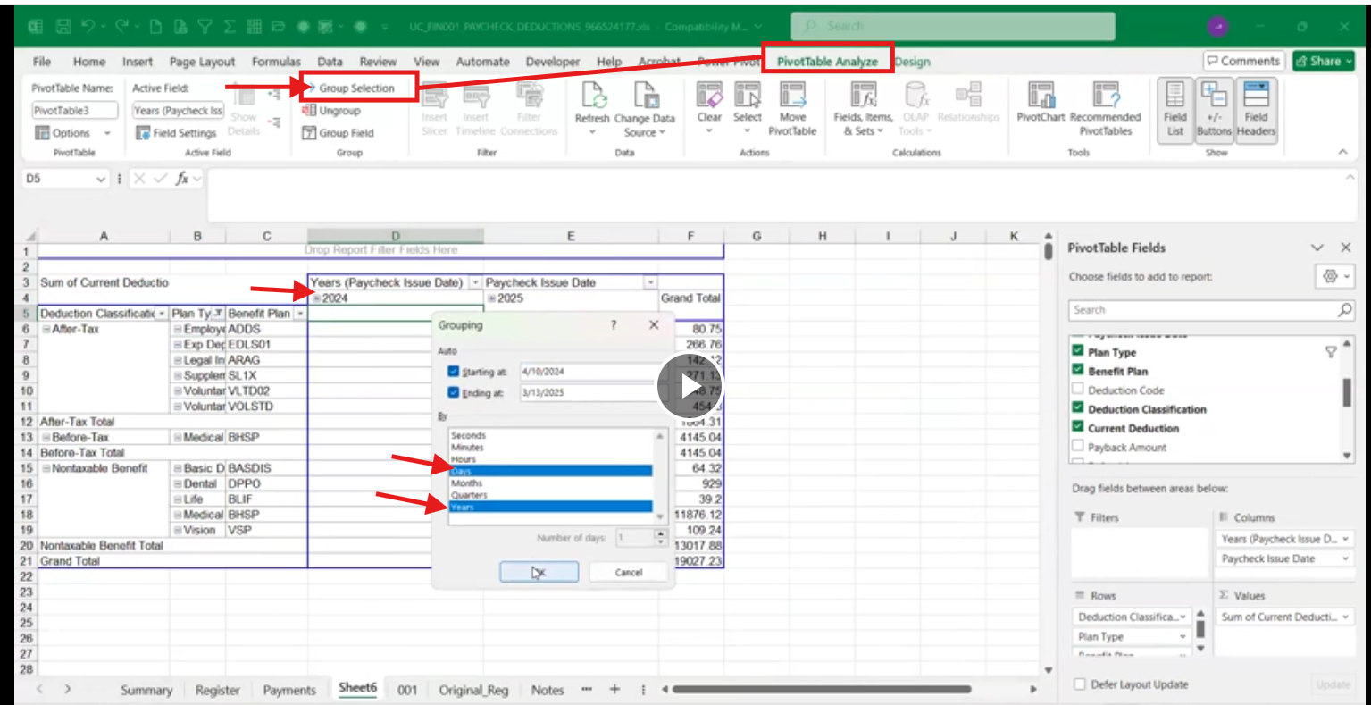

1. Copy the pivoted table and paste it on Summary sheet (which is blank initially)
   1. Reformatting (this cannot be automated)
      1. Split After-Tax – Voluntary LongTerm Disability and Voluntary ShortTerm Disability and place after Nontaxable Benefit rows
      2. Split Nontaxable Benefit – Basic Disability and place at the last row.

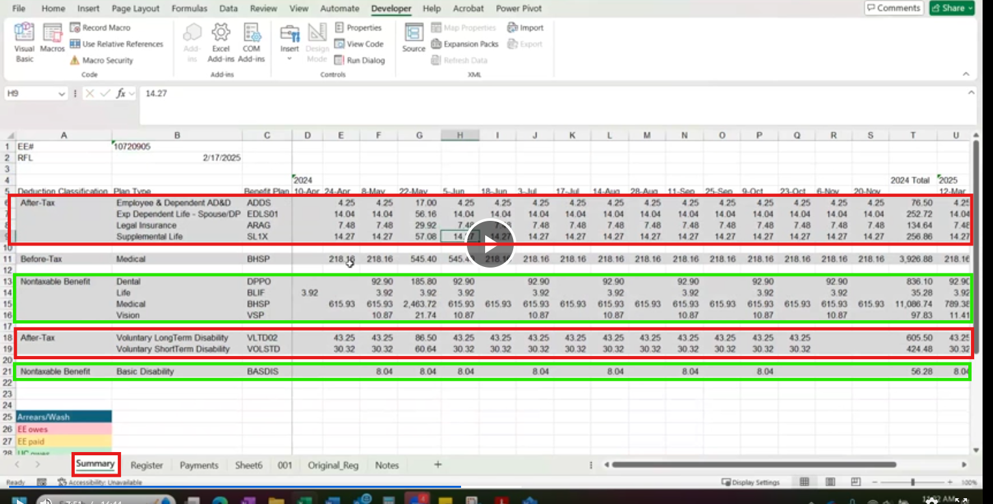

* 1. Run Key Macro – which adds legends starting at cell A30-A33, cell 35 and 43 and add EE# (cell A1) and RFL – Return From Leave date (at cell A2).
     1. Laura deletes row 23 – 27 (why?? This is not practical)
  2. As a way to indicate the variance of Medical rate, Laura manually highlights the Paycheck Issue Date cells where Medical rates are varied.

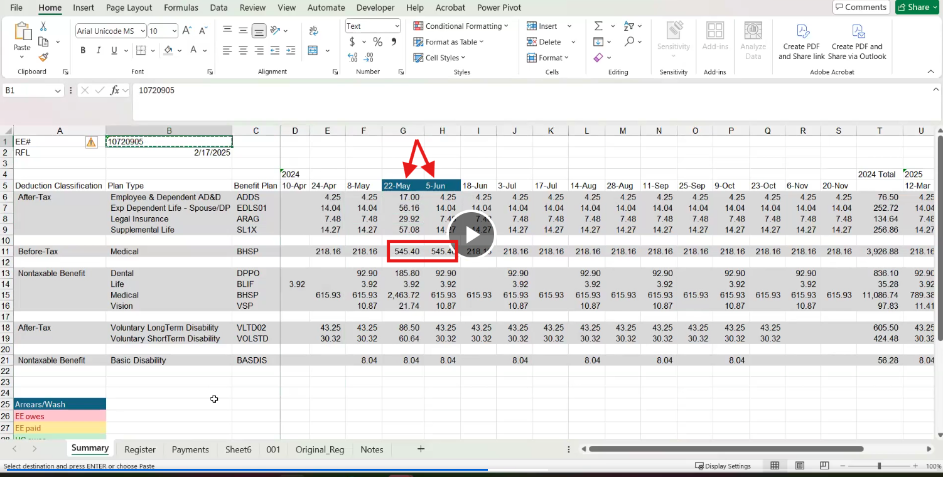

1. Processing Rears/Awash, previous recon
   1. Go to PS > Health Benefits put the **Emplid** and check Include History box

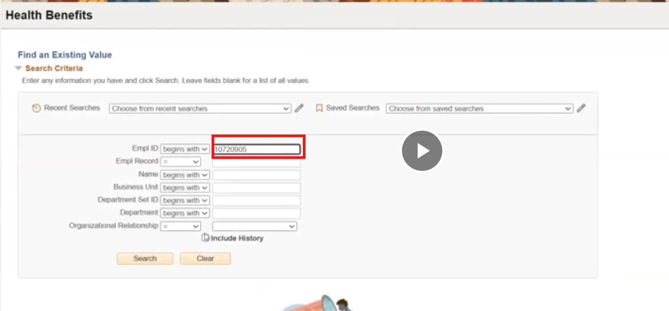

* 1. Check Coverage Begin Date and Deduction Begin Date

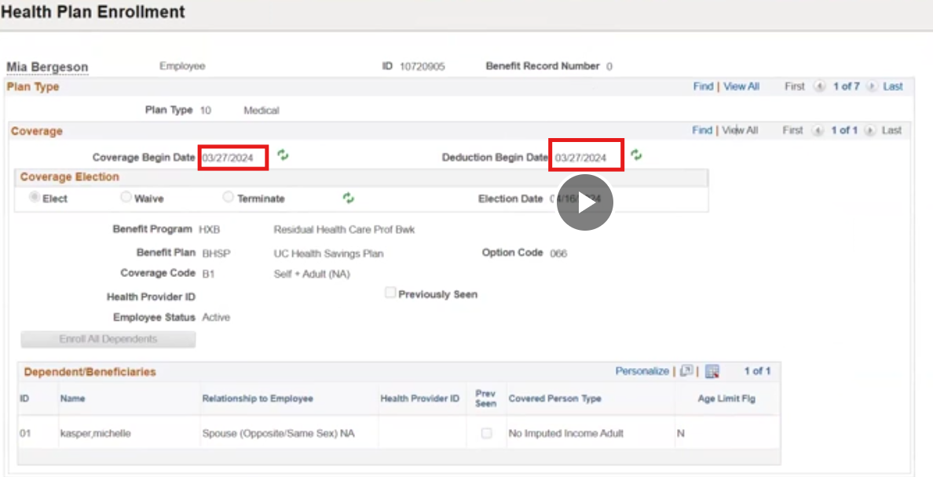.

* 1. Identify missing checks and consult [PYCK Dates.xlsx](https://ucofficeofthepresident.sharepoint.com/:x:/r/sites/RPAImplementation/Shared%20Documents/Analysis/UCPath%20Pilot%20Use%20Cases/Return%20from%20Leave%20Reconciliation/PYCK%20Dates.xlsx?d=wb14a61f4e0e84b30b196e046488a4927&csf=1&web=1&e=CS8hW0). Note: need more clarification on arrears/wash or what determines the need to insert Paycheck Issue date
  2. Determine the normal pay rates (?) and prepend the missing paychecks

1. Fill in the paycheck gap
   1. Laura identifies the gap from paycheck 11/20/2024 and 03/25/2025. She then insert 12/04/2024, 12/18/2024, 01/01/2025, 01/15/2025, 02/12/2025, 02/26/2025 based on [PYCK Dates.xlsx](https://ucofficeofthepresident.sharepoint.com/:x:/r/sites/RPAImplementation/Shared%20Documents/Analysis/UCPath%20Pilot%20Use%20Cases/Return%20from%20Leave%20Reconciliation/PYCK%20Dates.xlsx?d=wb14a61f4e0e84b30b196e046488a4927&csf=1&web=1&e=CS8hW0)

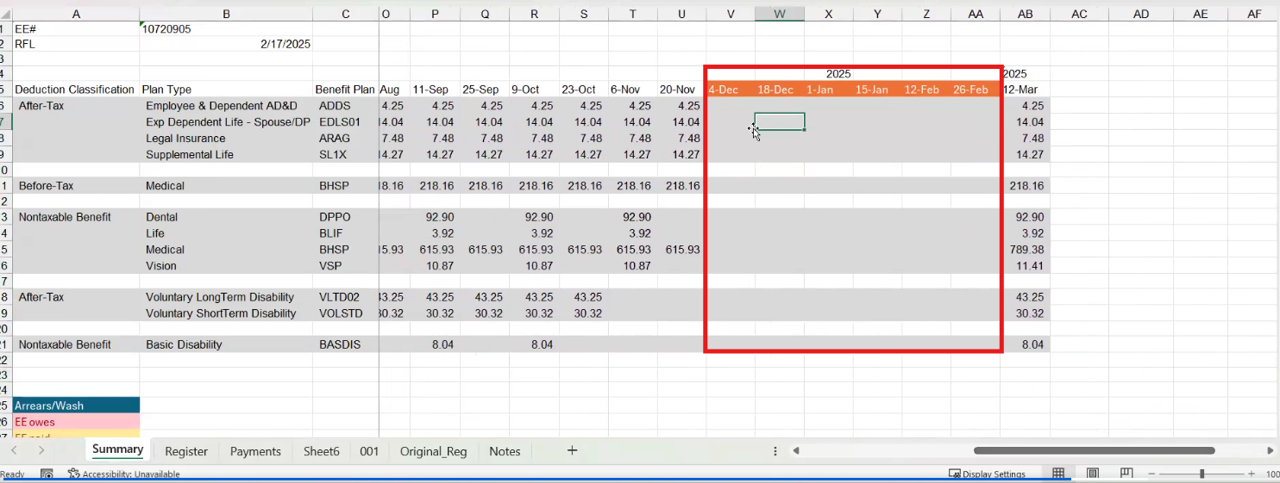

* 1. Laura copy and paste the value from paycheck 03/12/2025 onto the newly inserted columns

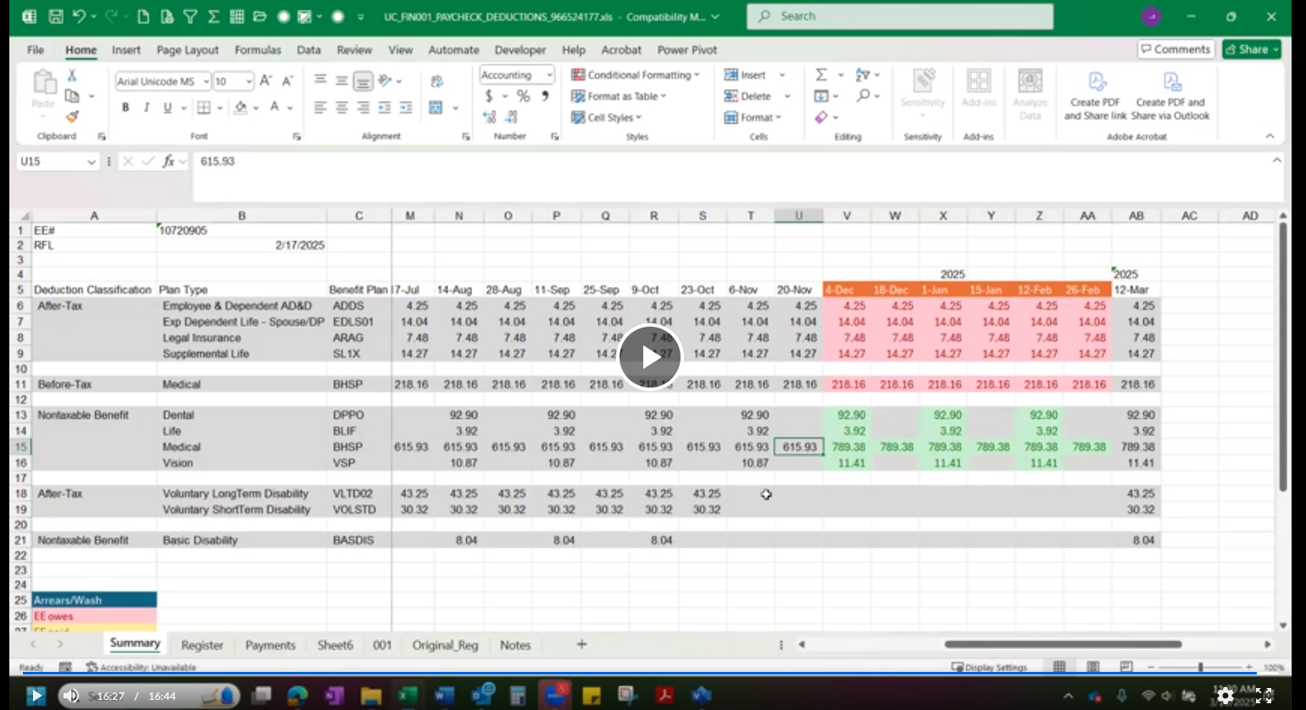

## Viewing Transactions in Oracle Billing

1. The reason for pulling a transaction report from OFC (Oracle Financial Cloud) is to see what these charges being billed for.
   1. Go to OFC > Billing

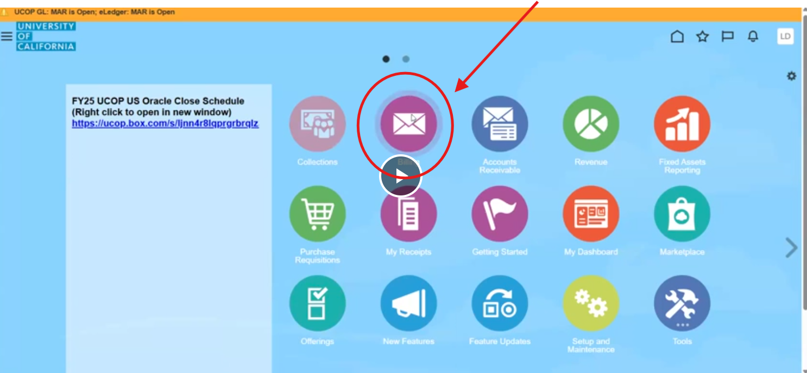

* 1. Click Review Customer Accounts to pull everything in his/her account

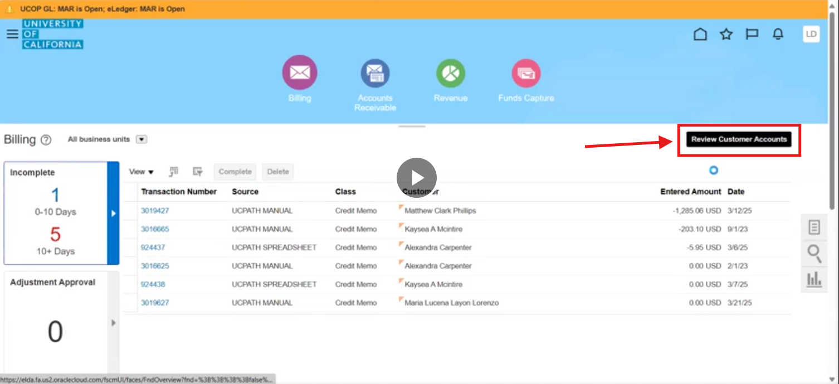

* 1. Paste the Emplid prepended with ‘E’. on Account Number

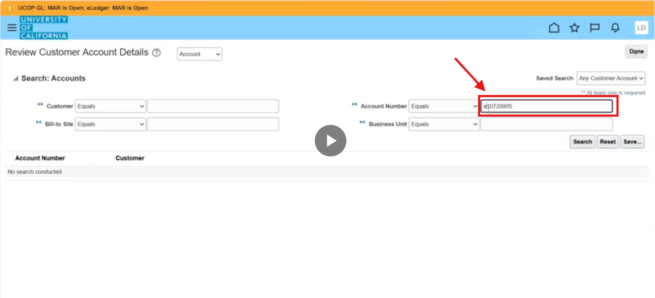

**Note**: Benefits Billing and Overpayment data

* 1. On the next screen, View Activities By – select All

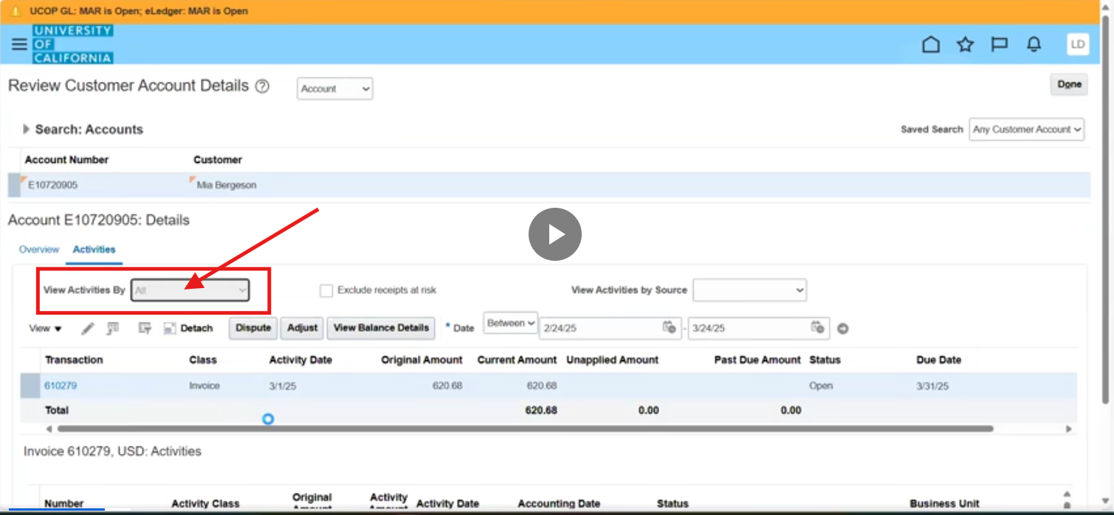

* 1. On Date, put as early as possible

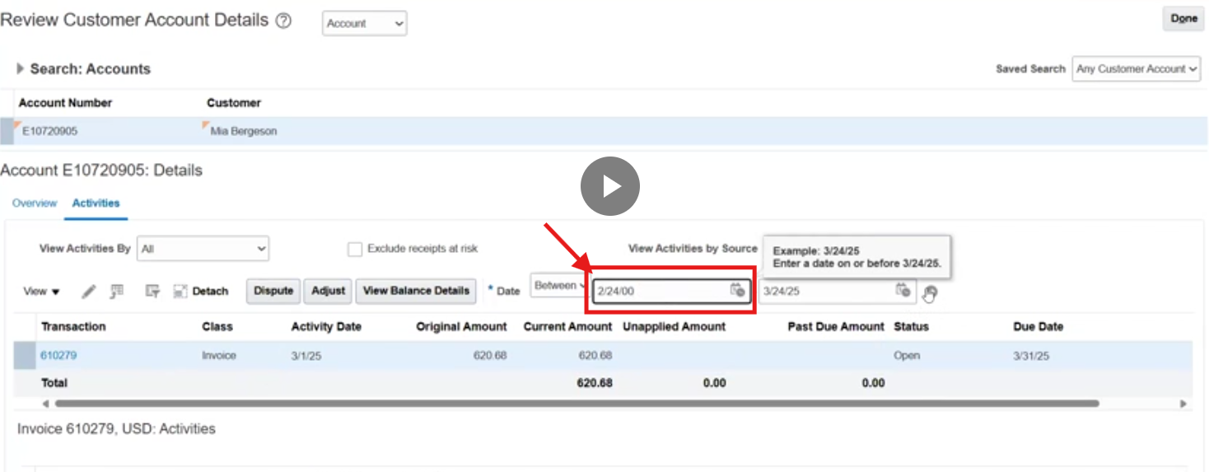

* 1. Click the arrow icon to generate the list of transactions

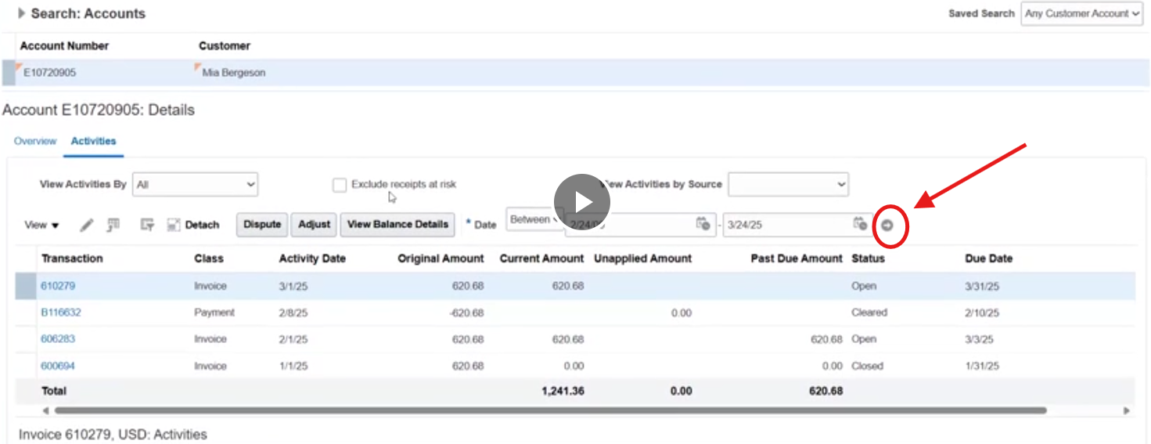

## Export Transaction Register from OFC

1. Open another window and login to OFC. Click Tools then Reports and Analytics

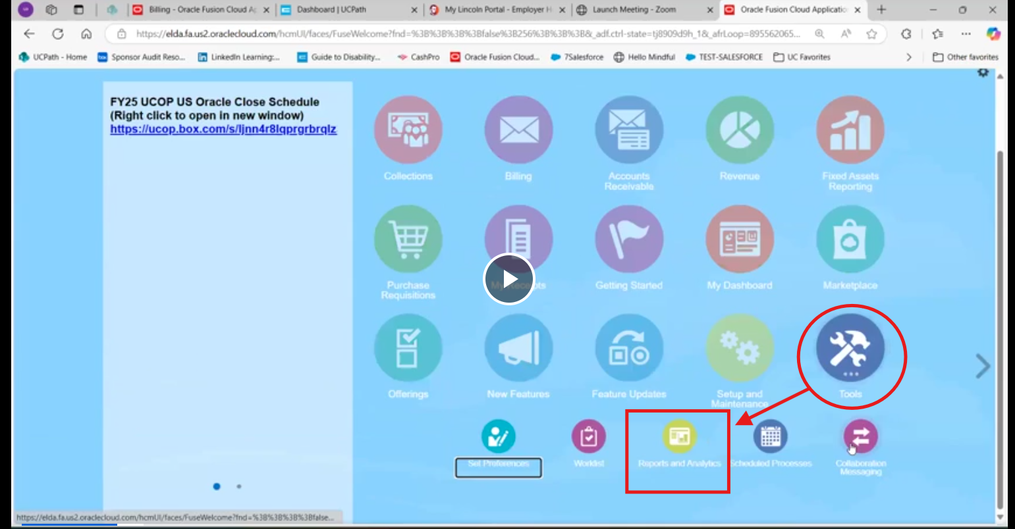

* 1. Select page 1 (Transaction Register Report)

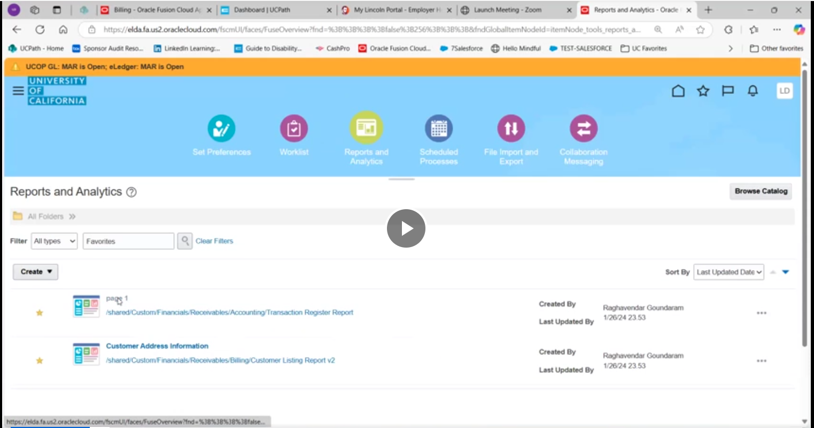

* 1. Paste Emplid with prepended ‘e’ on Bill-to-Customer Account Number and click Apply to pull invoices by line item

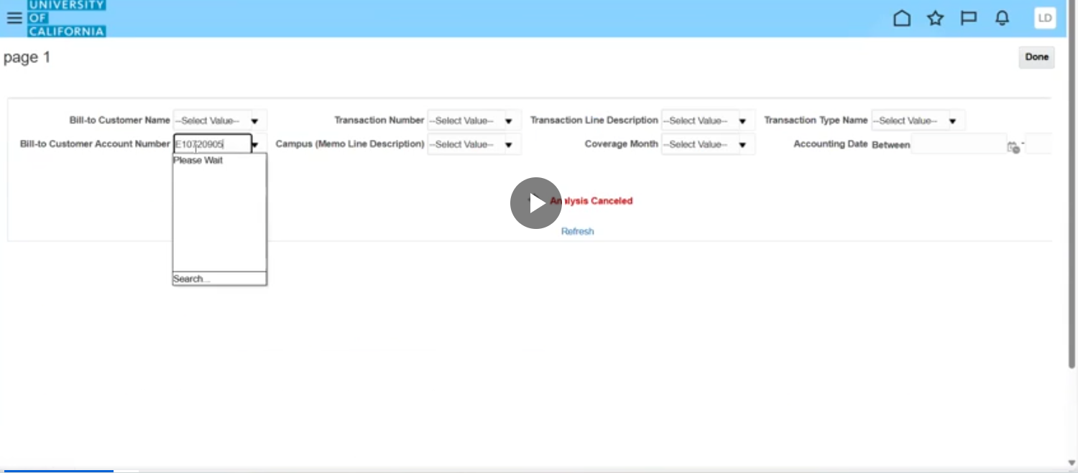

* 1. Select ‘Export’ > Data > CSV

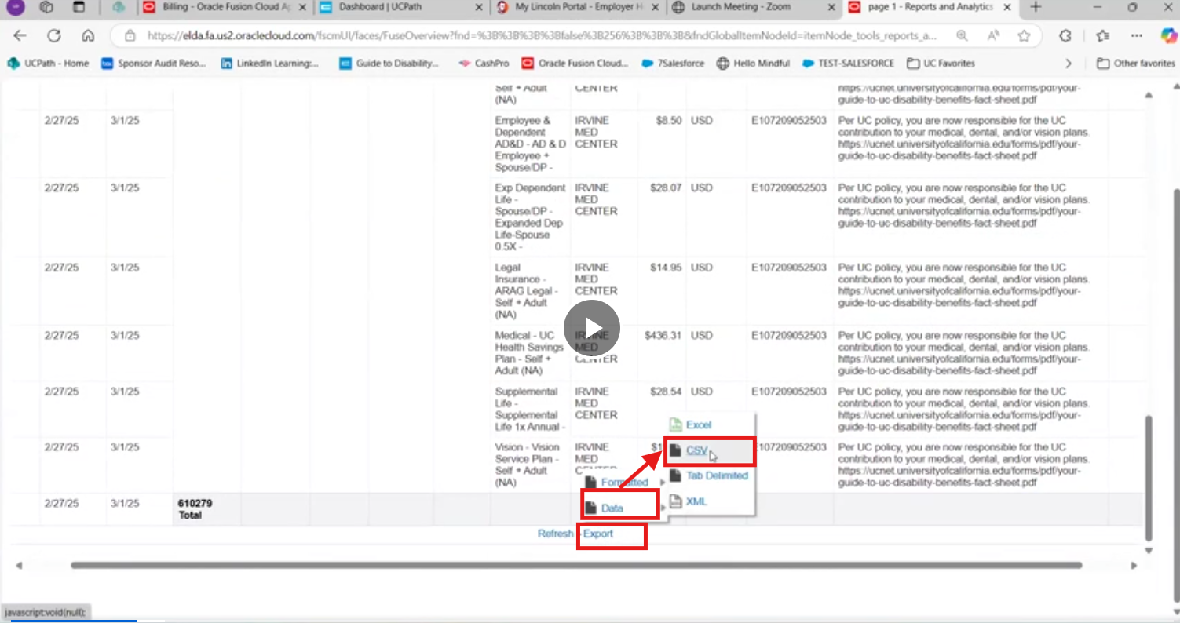

* 1. When Transaction Register Analysis report run Team_Register macro

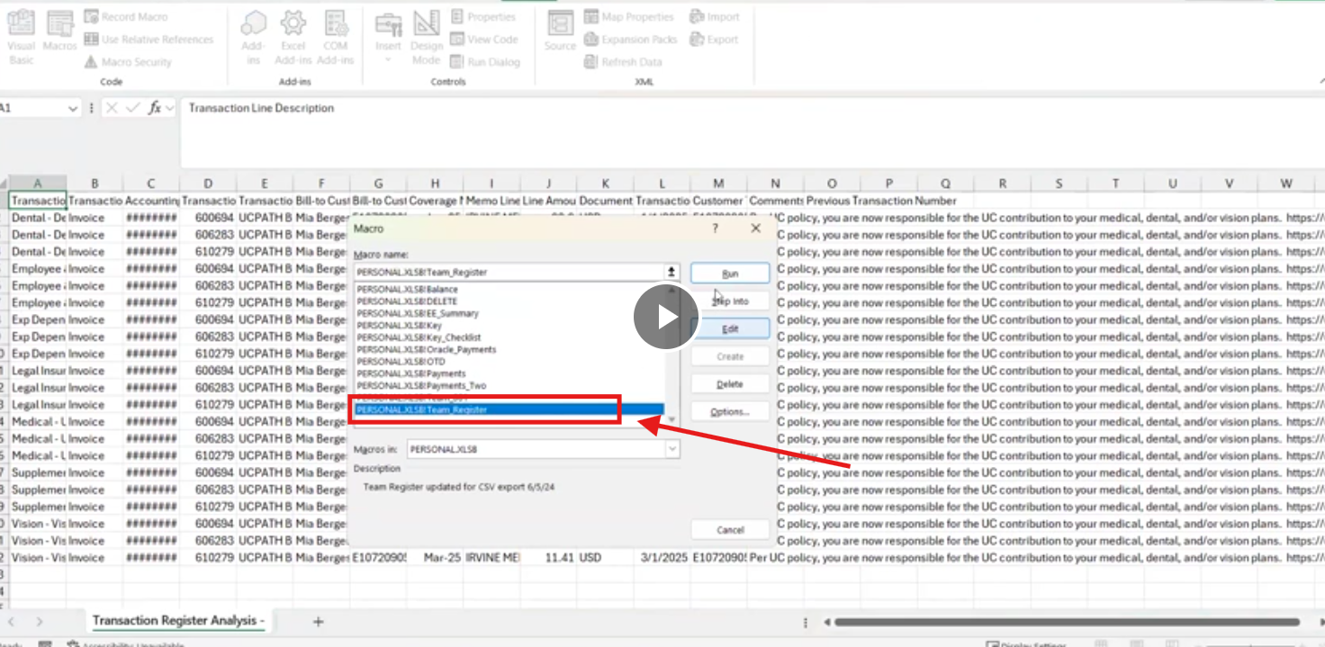

* + 1. Running Team_Register macro will rename and reorder columns as follow:
       1. Transaction (Col A) -> Description
       2. Transaction Date (Col K) -> Invoice Date
       3. Transaction Number (col D) -> Invoice #
       4. Bill-to-Customer ID (col G) -> EE ID
       5. Accounting Date (col C)
       6. Coverage Month (col H)
       7. Line Amount (col J) -> Amount
       8. Comments (col N)
       9. Previous Transaction Number (col O)
  1. Once Team_Register macro is ran, sort Invoice # ascending order. Run subtotal by Invoice # to Amount

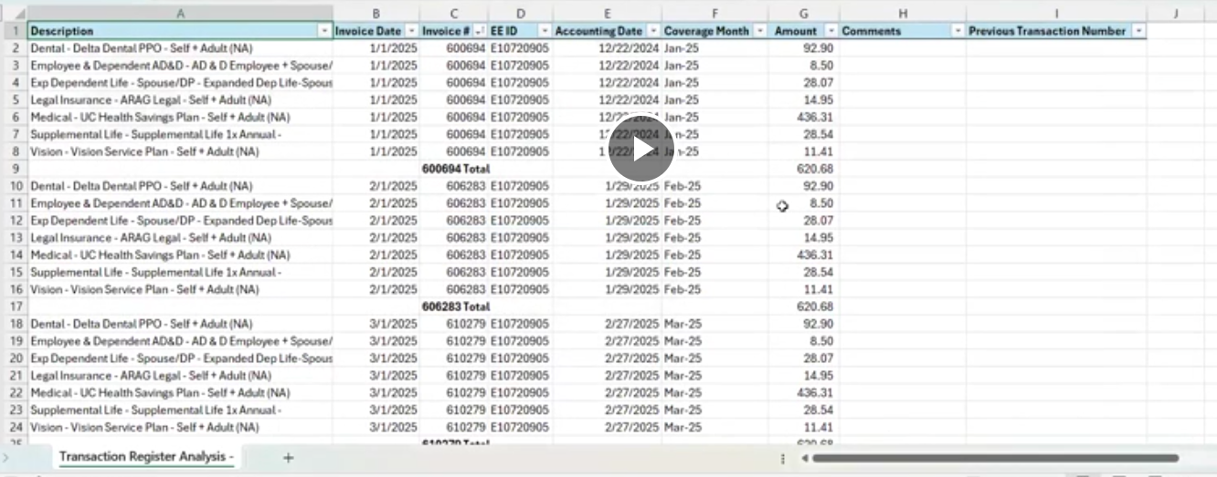

## Confirm In PeopleSoft Extended Absence

1. Go to PeopleSoft > Extended Absence

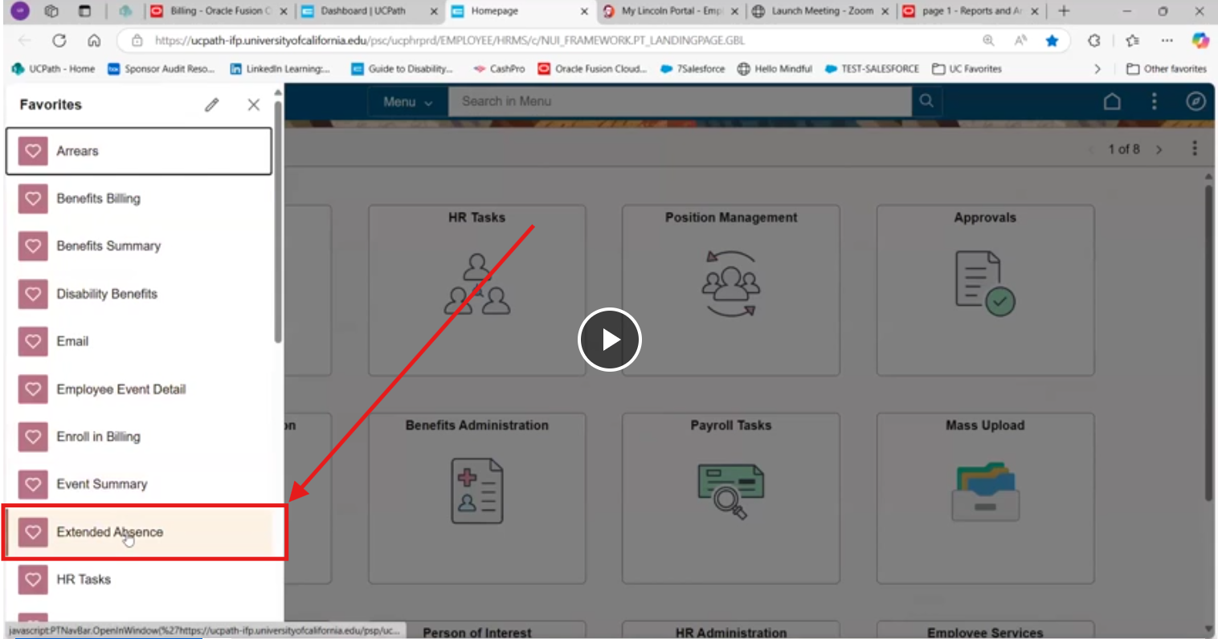

## ===================================================

Questions:

1. When TEAM_001 macro is ran, what does it do beside shuffling columns?
   1. On 001 worksheet, do the columns need to be in this specific orders?
      1. Employee ID
      2. Employee Name
      3. Business Unit
      4. Empl Status
      5. Employee Record
      6. Pay Group
      7. Paycheck Issue Date
      8. Plan Type
      9. Benefit Plan
      10. Deduction Code
      11. Deduction Classification
      12. Current Deduction
      13. Payback Amount
      14. Refund Amount
      15. Not Taken
      16. Reason
      17. Paycheck Status
      18. Paycheck Option
      19. Off Cycle
   2. What is the purpose of book(c ) .xlsx?
   3. Why Employee Status rows are all noted with ‘A’? Is there any case when Employee Status should not be noted as ‘A’?
2. When pivoting table in 001 workbook and filtering Plan Type, is this a fixed list of Plan Types to be filtered?
   1. Basic Disability, Dental, Employee & Dependent AD&D, Exp Dependent Life – Spouse/DP, Legal Insurance, Life, Medical, Supplemental Life, Vision, Voluntary Long Term Disability, Voluntary ShortTerm Disability
3. Is there a case when the employee is a Monthly instead of Bi-weekly?
   1. Is there a case when the employee switches from Bi-weekly to Monthly when the employee returns from leave? What does Pay Group indicate?
   2. Where is the Deduction Calendar in Quicklinks in Peoplesoft?
   3. Where is the Deduction Calendar on Sharepoint?
   4. Is [PYCK Dates.xlsx](https://ucofficeofthepresident.sharepoint.com/:x:/r/sites/RPAImplementation/Shared%20Documents/Analysis/UCPath%20Pilot%20Use%20Cases/Return%20from%20Leave%20Reconciliation/PYCK%20Dates.xlsx?d=wb14a61f4e0e84b30b196e046488a4927&csf=1&web=1&e=CS8hW0) provided in RPA Sharepoint the same Paycheck Issue Date from Payroll Calendar?
4. What is the purpose of creating Summary, Register, Payments, Original_Reg, and Notes sheets in the workbook? Are these sheets blank initially?
5. Notes: The copy and pasting pivot table from 001 into Summary sheet is fine but re-formatting the presentation is not practical. Once the pivot table is generated, we cannot split the rows for presentation purpose.
6. Explain the arrears/ wash -or- previous recon. Note: starting at minute 8:20 – 11:35 of the 1st demo video
7. How is Oracle Financial Cloud account provisioned?
   1. What roles/ permissions needed to be able to pull Transaction Register report?
8. When pulling Transaction Register report in OFC, how to distinguish Overpayment vs. Benefits Billing Data? We need example
9. What is the purpose of reviewing Customer account details within OFC Billing?
10. Do we need to export transaction register regardless if there’s transactions or not?
11. We need a sample of transaction register analysis report
12. Lincoln Financials Group – to check disability claim. Is this a requirement for bot to check disability claim? Does Lincoln Financial Group allow bot to run on their web site?

Thoughts/ Comments/ Concerns:

1. In case of missing paycheck -or- gap in paycheck, we need to be able to list all dates under Paycheck Issue Date (col. G) and compare against the list of Paycheck dates (on PYCK_dates.xlsx; link: [PYCK Dates.xlsx](https://ucofficeofthepresident.sharepoint.com/:x:/r/sites/RPAImplementation/Shared%20Documents/Analysis/UCPath%20Pilot%20Use%20Cases/Return%20from%20Leave%20Reconciliation/PYCK%20Dates.xlsx?d=wb14a61f4e0e84b30b196e046488a4927&csf=1&web=1&e=CS8hW0)). Then we need to do the following:
   1. In the raw UC_FIN001_PAYCHECK_DEDUCTION_XXXX.xls workbook, we need to add rows of the missing Paycheck Issue Date
   2. The rows consist of **duplicated** data from the following columns:
      1. Business Unit
      2. Employee ID
      3. Employee Record
      4. Employee Name
      5. Pay Group
      6. Employee Type
      7. Refund Amount
      8. Not Taken
      9. Reason
      10. Calculated Base
      11. Paycheck Status
      12. Paycheck Option
      13. Off Cycle
   3. NOTE: every pay period Columns Plan Type, Benefit Plan, Deduction Code, Deduction Code Descr., Deduction Classification have a pattern *** need to think about how to apply the pattern to gap dates***
   4. NOTE: need a list of paycheck issue dates and compare against the list of paycheck issue dates from FIN001 report to identify gaps.
2. Need to find a way to insert Subtotal into dataframe 

Strategy:

* 1. Create a sample of Transaction Register Analysis workbook
  2. Link: <https://www.youtube.com/watch?v=8rEV7nKMF0I&list=WL&index=1&t=561s>
  3. Create empty list container = []
  4. For label, _df in df.groupby([‘Invoice #’,]):

_df.loc[f’{label[0]} Total’] = _df[‘Amount’].sum()